**Practical No.07**

1. **Add Access point, pc, laptop, wireless tablet**

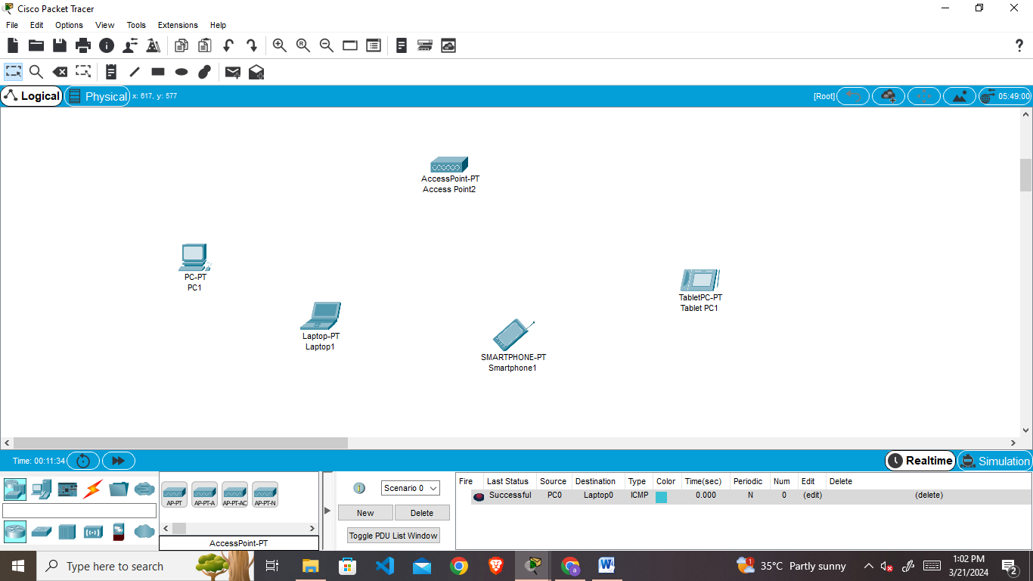

1. **Add port on pc and laptop**

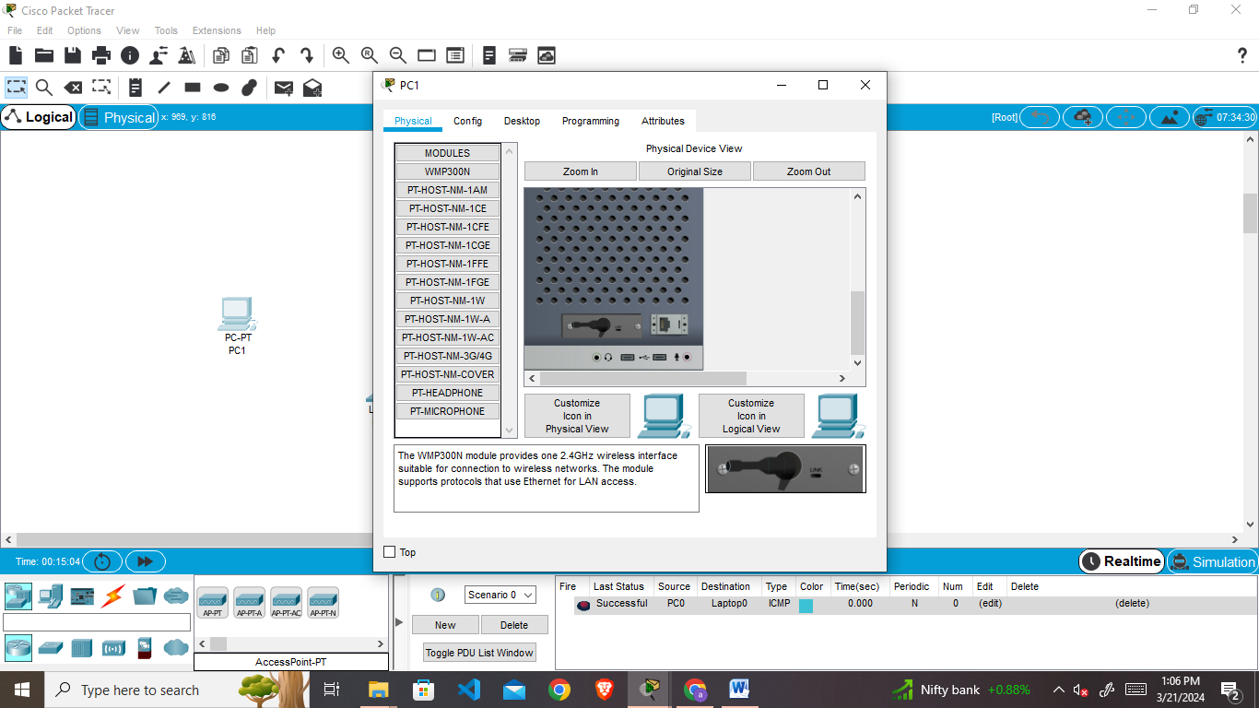

1. **Click on Access point**

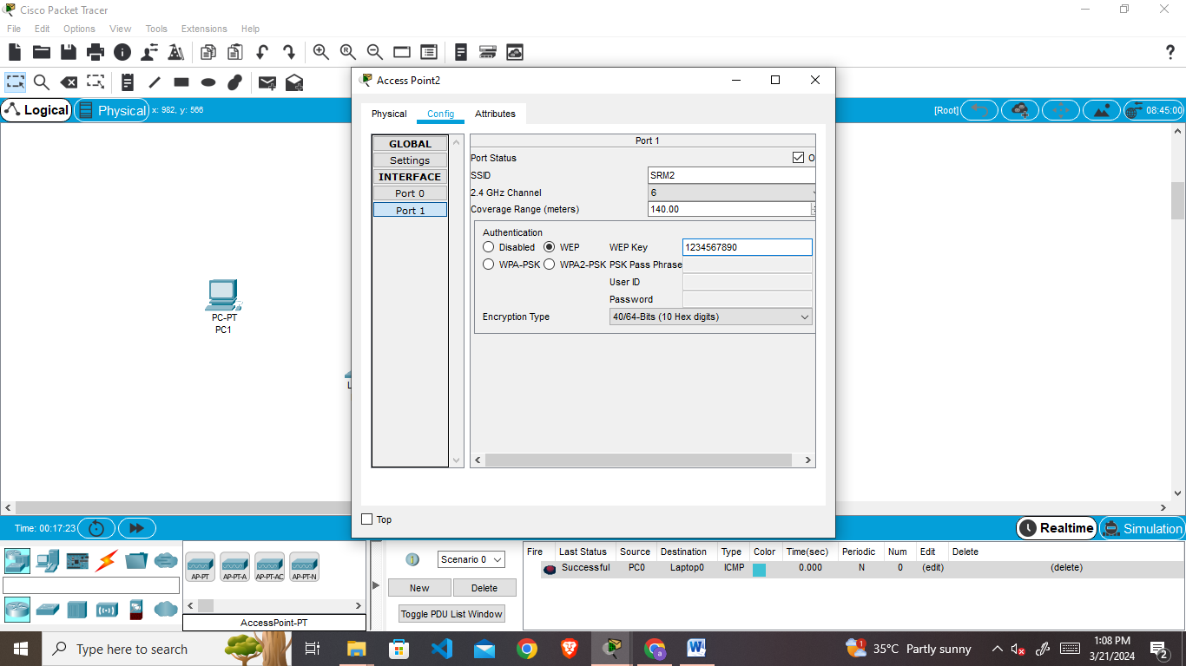

1. **Click on Tablet**

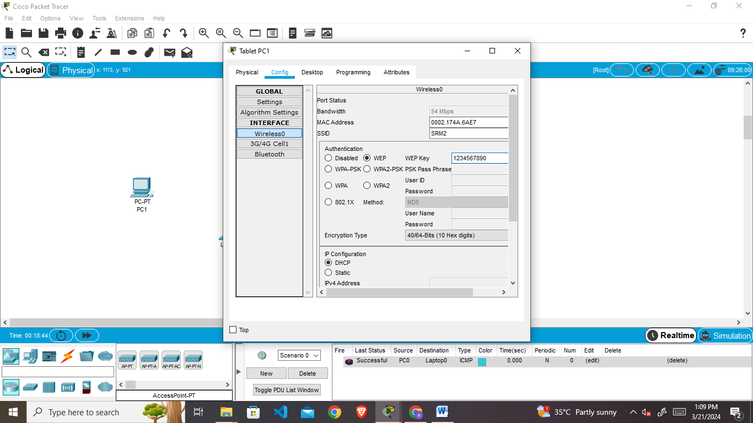

1. **Change the port of laptop and click on desktop- pc wireless- connect**

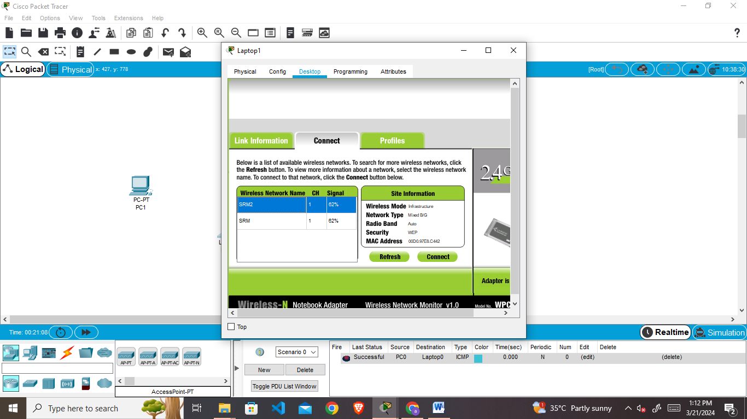

1. **Enter the wep key**

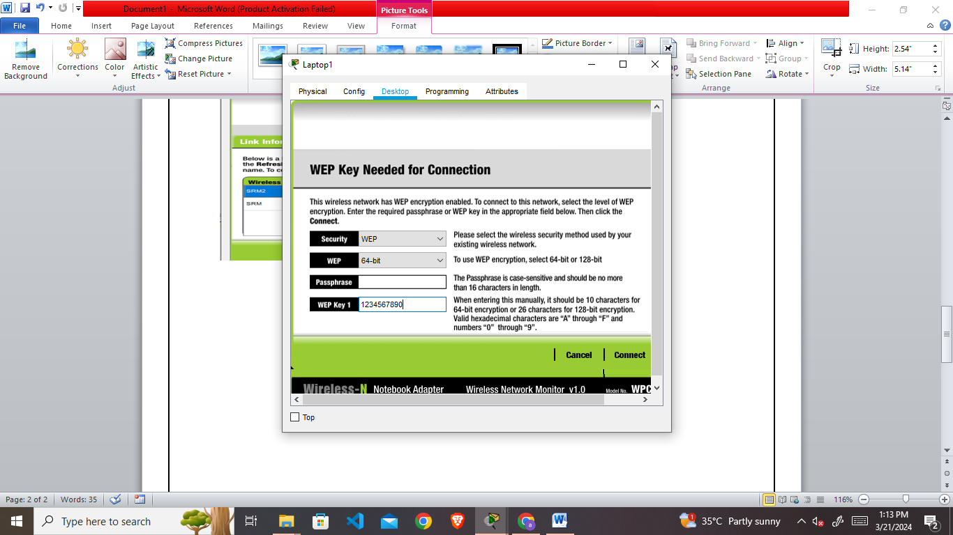

1. **Connect the pc**

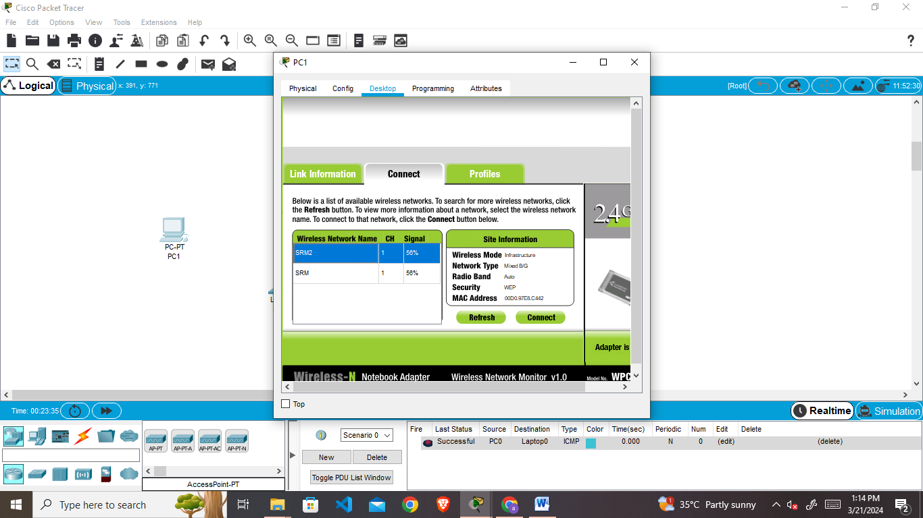

1. **After connection send the packet Pc to laptop**

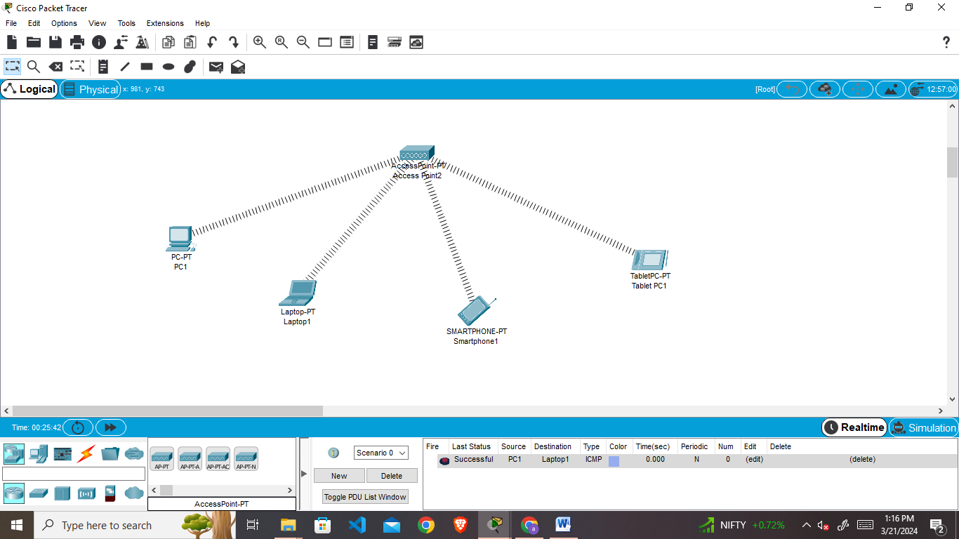

1. **Pc to smartphone**

